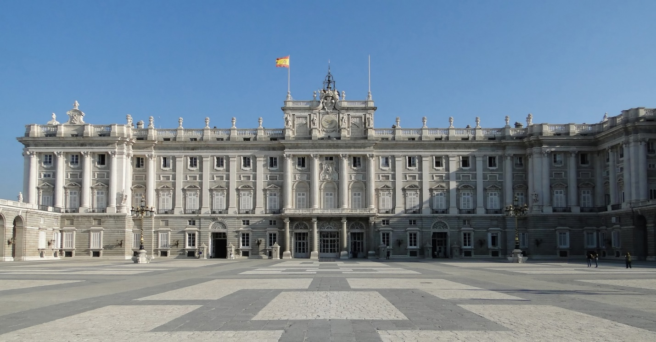

# Royal Palace of Madrid

The **Royal Palace of Madrid** ([Spanish](https://en.wikipedia.org/wiki/Spanish_language): *Palacio Real de Madrid*) is the official residence of the [Spanish royal family](https://en.wikipedia.org/wiki/Spanish_royal_family) at the city of [Madrid](https://en.wikipedia.org/wiki/Madrid), although now used only for state ceremonies. The palace has 135,000 m2 (1,450,000 sq ft) of floor space and contains 3,418 rooms.[[1]](https://en.wikipedia.org/wiki/Royal_Palace_of_Madrid#cite_note-rooms-1)[[2]](https://en.wikipedia.org/wiki/Royal_Palace_of_Madrid#cite_note-biggestpalace-2) It is the largest royal palace in [Europe](https://en.wikipedia.org/wiki/Europe).[[3]](https://en.wikipedia.org/wiki/Royal_Palace_of_Madrid#cite_note-3)

The palace is owned by the Spanish state and administered by the [Patrimonio Nacional](https://en.wikipedia.org/wiki/Patrimonio_Nacional" \o "Patrimonio Nacional), a public agency of the [Ministry of the Presidency](https://en.wikipedia.org/wiki/Ministry_of_the_Presidency).[[4]](https://en.wikipedia.org/wiki/Royal_Palace_of_Madrid#cite_note-FOOTNOTESancho20147-4) The palace is on Calle de Bailén ("Bailén Street") in the western part of downtown Madrid, east of the [Manzanares River](https://en.wikipedia.org/wiki/Manzanares_River" \o "Manzanares River), and is accessible from the [Ópera metro station](https://en.wikipedia.org/wiki/%C3%93pera_(Madrid_Metro)" \o "Ópera (Madrid Metro)). [Felipe VI](https://en.wikipedia.org/wiki/Felipe_VI) and the royal family do not reside in the palace, choosing instead the [Palace of Zarzuela](https://en.wikipedia.org/wiki/Palace_of_Zarzuela) in [El Pardo](https://en.wikipedia.org/wiki/El_Pardo).

The palace is on the site of a bygone Muslim-era fortress constructed by Emir [Muhammad I of Córdoba](https://en.wikipedia.org/wiki/Muhammad_I_of_C%C3%B3rdoba) in the 9th century.[[5]](https://en.wikipedia.org/wiki/Royal_Palace_of_Madrid#cite_note-FOOTNOTEViso20147-5) The imposing [Alcázar of Madrid](https://en.wikipedia.org/wiki/Royal_Alc%C3%A1zar_of_Madrid" \o "Royal Alcázar of Madrid) provided both a safe for the royal treasure and a habitual residence to the [Trastámara](https://en.wikipedia.org/wiki/House_of_Trast%C3%A1mara" \o "House of Trastámara) monarchs in the late Middle Ages.[[6]](https://en.wikipedia.org/wiki/Royal_Palace_of_Madrid#cite_note-6) Having endured substantial expansion works during the 16th century, the royal *alcázar* remained on the site until it burned down on 24 December 1734. A new palace was then built from scratch on the same site on behalf of the [Bourbon dynasty](https://en.wikipedia.org/wiki/House_of_Bourbon-Anjou). Construction spanned the years 1738 to 1755[[7]](https://en.wikipedia.org/wiki/Royal_Palace_of_Madrid#cite_note-patromonio-7) and followed a [Berniniesque](https://en.wikipedia.org/wiki/Bernini" \o "Bernini) design by [Filippo Juvarra](https://en.wikipedia.org/wiki/Filippo_Juvarra) and Giovanni Battista Sacchetti in cooperation with [Ventura Rodríguez](https://en.wikipedia.org/wiki/Ventura_Rodr%C3%ADguez), [Francesco Sabatini](https://en.wikipedia.org/wiki/Francesco_Sabatini), and [Martín Sarmiento](https://en.wikipedia.org/wiki/Mart%C3%ADn_Sarmiento). During the [Second Spanish Republic](https://en.wikipedia.org/wiki/Second_Spanish_Republic) the building was known as "Palacio Nacional".

The interior of the palace is notable for its wealth of art and the use of many types of fine materials in the construction and the decoration of its rooms. It includes paintings by artists such as [Caravaggio](https://en.wikipedia.org/wiki/Caravaggio), [Juan de Flandes](https://en.wikipedia.org/wiki/Juan_de_Flandes), [Francisco de Goya](https://en.wikipedia.org/wiki/Francisco_de_Goya), and [Diego Velázquez](https://en.wikipedia.org/wiki/Diego_Vel%C3%A1zquez), and frescoes by [Giovanni Battista Tiepolo](https://en.wikipedia.org/wiki/Giovanni_Battista_Tiepolo), [Corrado Giaquinto](https://en.wikipedia.org/wiki/Corrado_Giaquinto" \o "Corrado Giaquinto), and [Anton Raphael Mengs](https://en.wikipedia.org/wiki/Anton_Raphael_Mengs). Many of the paintings at some time hung in the palace as part of the [Spanish royal collection](https://en.wikipedia.org/wiki/Spanish_royal_collection) are exhibited elsewhere, especially in the [Prado Museum](https://en.wikipedia.org/wiki/Prado_Museum) and the [Royal Collections Gallery](https://en.wikipedia.org/wiki/Royal_Collections_Gallery), both in Madrid.

Other collections of great historical and artistic importance preserved in the building include the [Royal Armoury of Madrid](https://en.wikipedia.org/wiki/Royal_Armoury_of_Madrid), porcelain, watches, furniture, silverware, and the world's only complete [Stradivarius](https://en.wikipedia.org/wiki/Stradivarius) string quintet.

## **History of the building**

The palace was initially built by Muhammad I, [Umayyad](https://en.wikipedia.org/wiki/Umayyad) [Emir](https://en.wikipedia.org/wiki/Emir) of [Cordoba](https://en.wikipedia.org/wiki/Umayyad_state_of_C%C3%B3rdoba), between 860 and 880. After the Moors were driven out of [Toledo](https://en.wikipedia.org/wiki/Toledo,_Spain) in the 11th century, the castle retained its defensive function. [Henry III of Castile](https://en.wikipedia.org/wiki/Henry_III_of_Castile) added several towers. His son [John II](https://en.wikipedia.org/wiki/John_II_of_Castile) used it as a royal residence.[[5]](https://en.wikipedia.org/wiki/Royal_Palace_of_Madrid#cite_note-FOOTNOTEViso20147-5) During the [War of the Castilian Succession](https://en.wikipedia.org/wiki/War_of_the_Castilian_Succession) (1476) the troops of [Joanna la Beltraneja](https://en.wikipedia.org/wiki/Joanna_la_Beltraneja) were besieged in the alcázar, during which the building suffered severe damage.

The only drawing of the castle from the [Middle Ages](https://en.wikipedia.org/wiki/Middle_Ages) is one from 1534 by [Jan Cornelisz Vermeyen](https://en.wikipedia.org/wiki/Jan_Cornelisz_Vermeyen).[[5]](https://en.wikipedia.org/wiki/Royal_Palace_of_Madrid#cite_note-FOOTNOTEViso20147-5)

Emperor [Charles V](https://en.wikipedia.org/wiki/Charles_V,_Holy_Roman_Emperor), with the architects [Alonso de Covarrubias](https://en.wikipedia.org/wiki/Alonso_de_Covarrubias) and [Luis de Vega](https://en.wikipedia.org/wiki/Luis_de_Vega), extended and renovated the castle in 1537. [Philip II](https://en.wikipedia.org/wiki/Philip_II_of_Spain) made Madrid his capital in 1561 and continued the renovations, with new additions. [Philip III](https://en.wikipedia.org/wiki/Philip_III_of_Spain) and [Philip IV](https://en.wikipedia.org/wiki/Philip_IV_of_Spain) added a long southern façade between 1610 and 1636.